***REPORT – Floreant POS App***

Contents

Introduction: 1

2pm Monday 1

3pm 2

4pm-5pm 3

5pm-6pm 3

6pm-7pm 3

7pm-9pm 3

10pm-11pm 4

9am-10am Tuesday 4

11am-12pm 5

12pm-1pm 5

1pm-4pm 6

4pm-6pm 7

Introduction: It takes 26 hours from 2pm Monday to 4pm Tuesday to get into the runnable Floreant POS open source code; however, it takes me only 2 hours to remove the Pin Code function. This task is really interesting thing for me to practise coz I learned more about Hibernate dependencies, Maven dependencies… The final source code runs well in Netbeans and Eclipse.

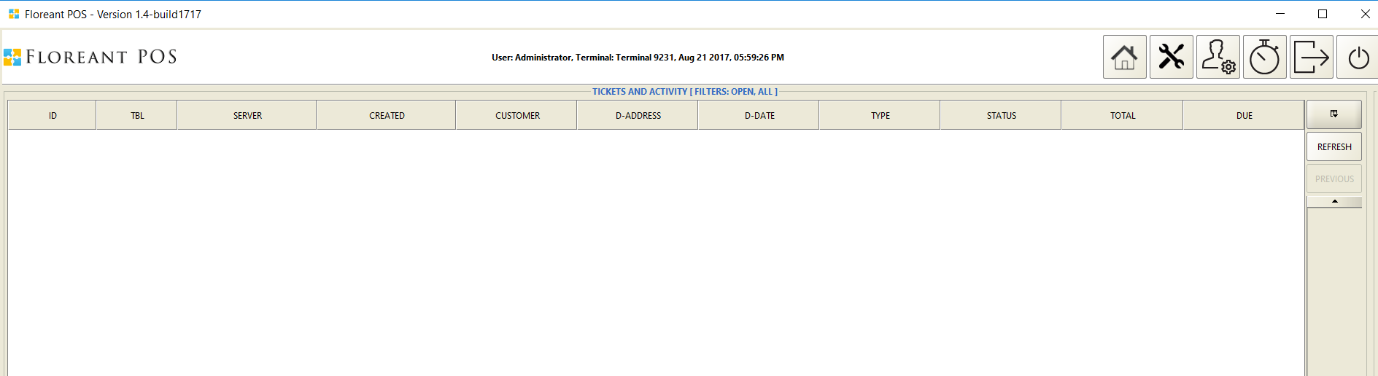

2pm Monday: I was not familiar with the website interface and got frustrated from the PayPal requirement so I was on the wrong track when I didn’t download the source code files from svn, but the binary files. Because I thought that you want to test my ability so I thought you want me to crack it so we can skip the password dialog.

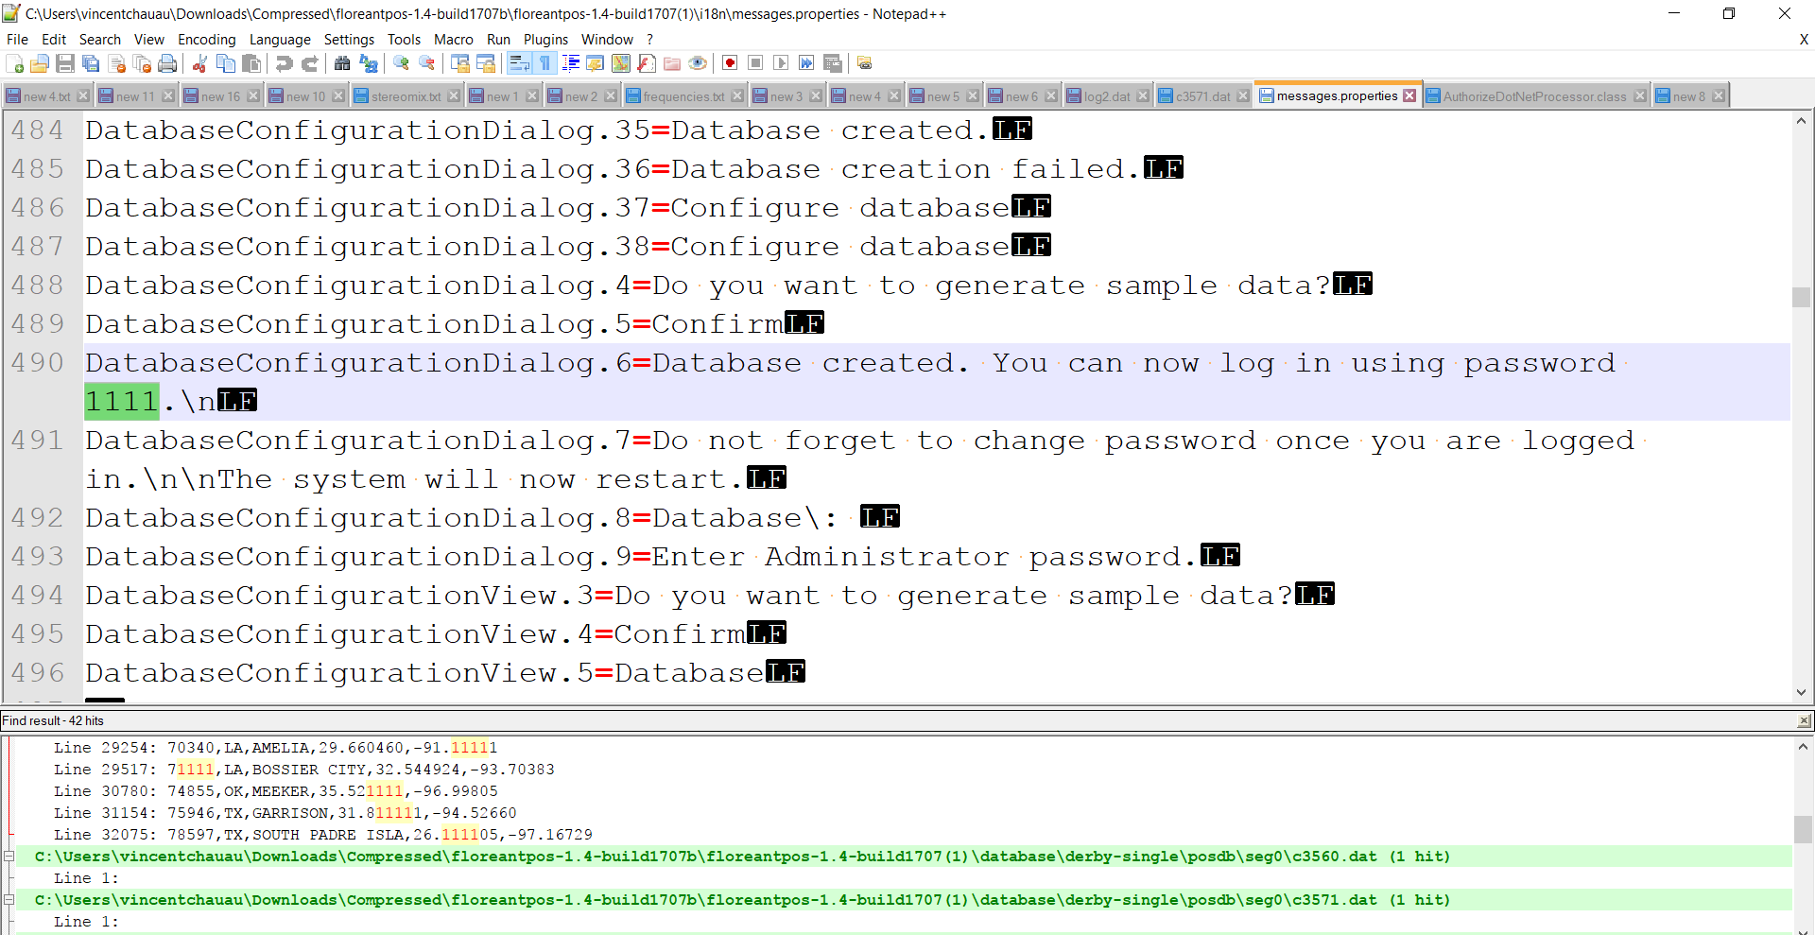

3pm: I came up with the idea of disassemble the .jar files to .class files by WinRar or JD disassembler. I found files including the text “1111”.

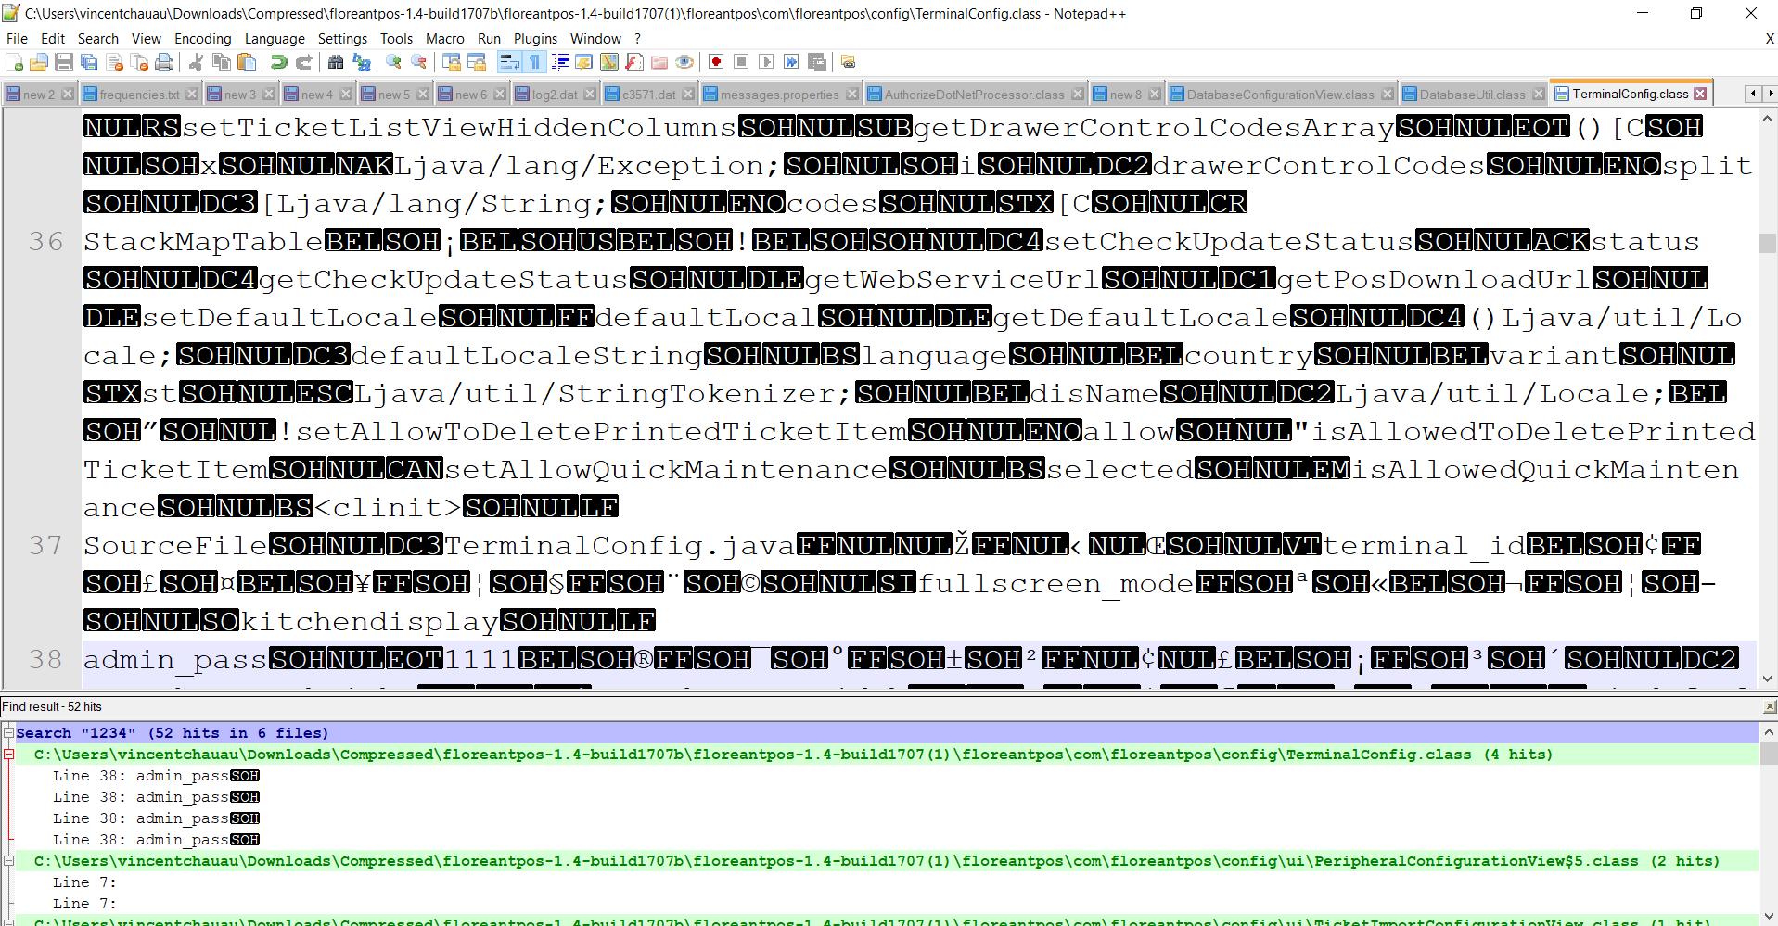

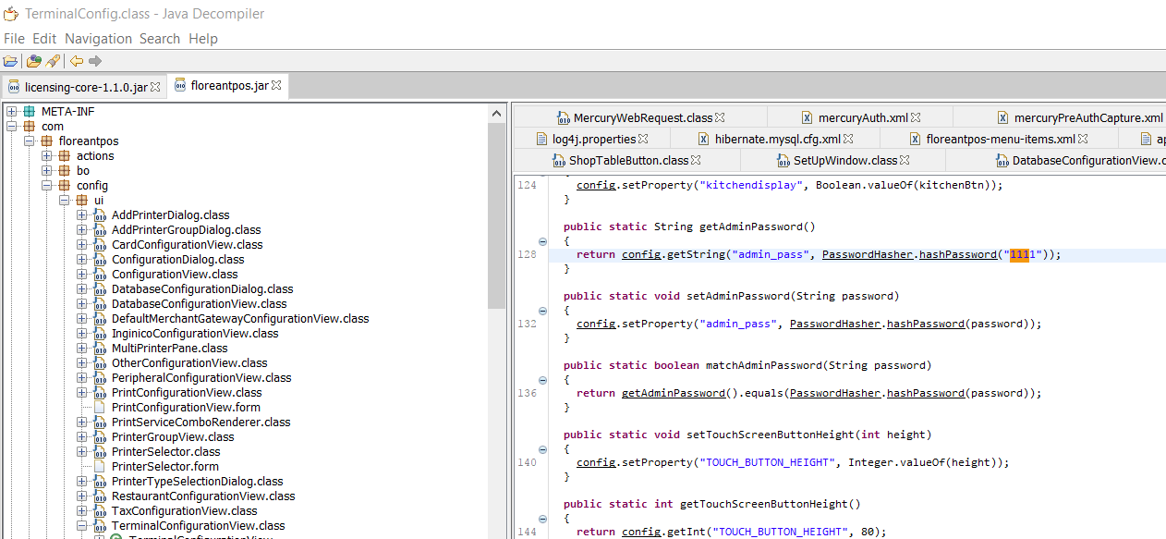

I wondered how I can assemble the .class files again to .jar files.

4pm-5pm: I took a nap

5pm-6pm: I read your email again, I found something like a trunk svn and tried to figure out the svn link from the Florant website.

I tried to open the project with Netbeans which is an often used tool for me but it was unsuccessful and started reading your email again and found something like environment configuration.

6pm-7pm:

I had something for my dinner and relaxed a bit.

7pm-9pm:

Honestly, I don’t use Eclipse a lot, so I got missing libs errors such as common loggin libs then I found this instruction link to set up Florant source code on Eclipse.

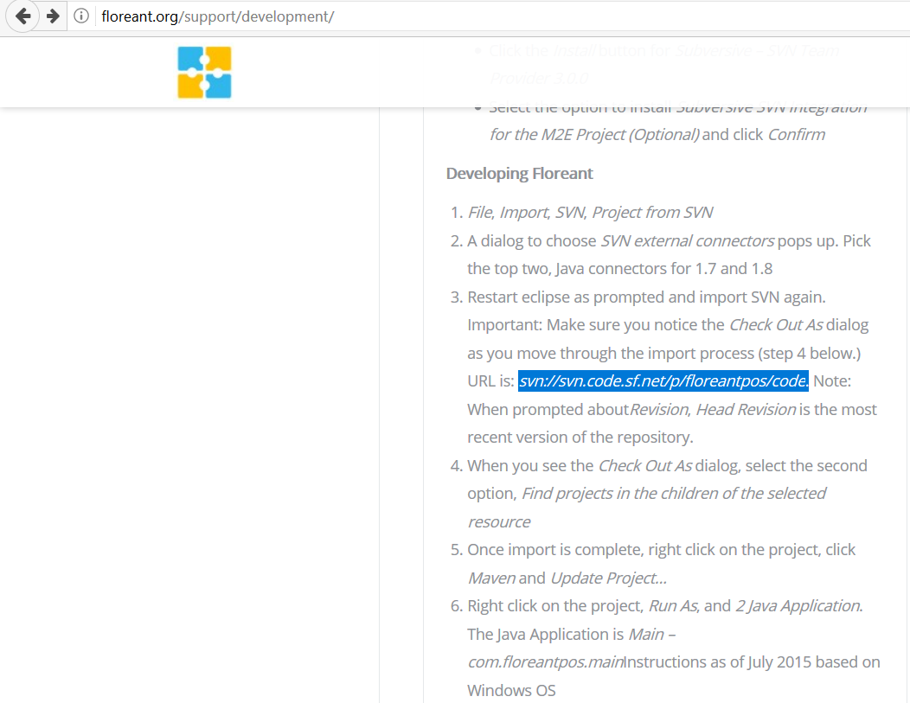

It was a bit slow downloading svn trunk and installing the new package from Eclipse Market.

10pm-11pm: Still missed some thing

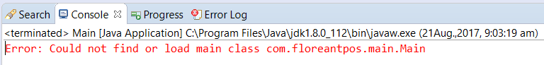

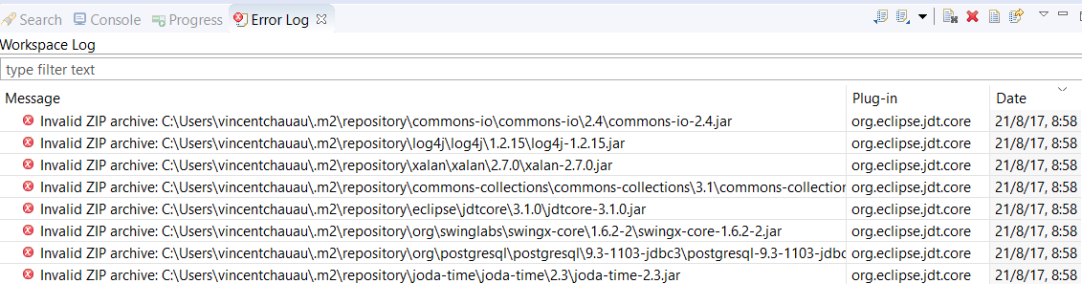

9am-10am Tuesday: Found the solution and built the app successfully with Netbeans

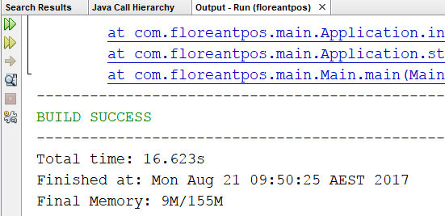

Found the error for missing hibernate on Eclipse, I didn’t know why my IDE didn’t inform this error yesterday’s night.

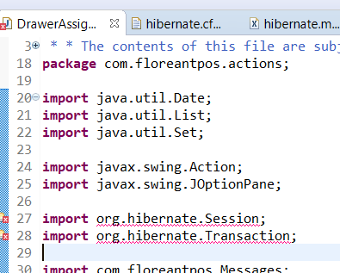

I found the solution, I had to delete “repository” folder then install mvn package again.

11am-12pm: I took a break

12pm-1pm: Built successfully on Netbeans, Eclipse; however, database connection error. I debugged the database connection and test the database by Razor DB and Squirrel DB and read them successfully.

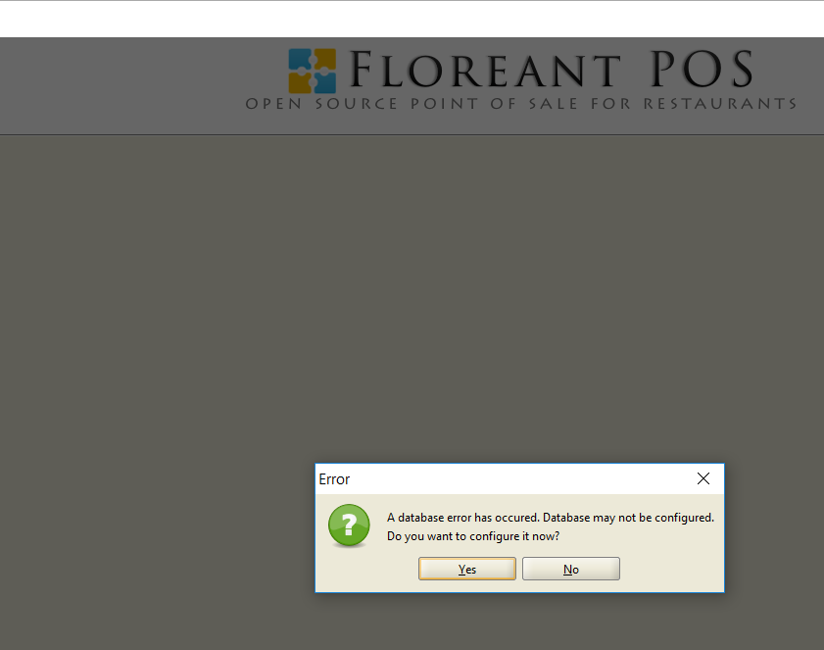

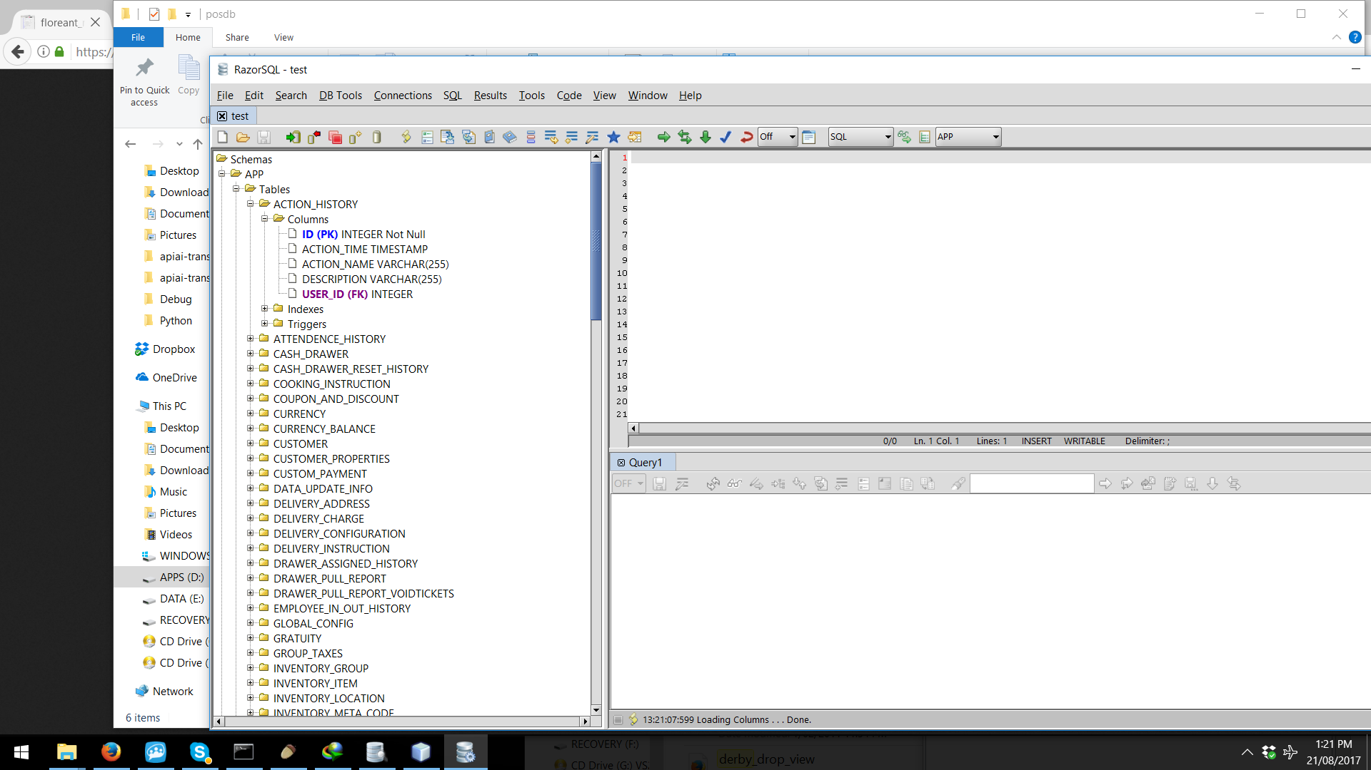

1pm-4pm: I got stuck with database connection. Then I found the solution by turning on the Derby Server service for database server.

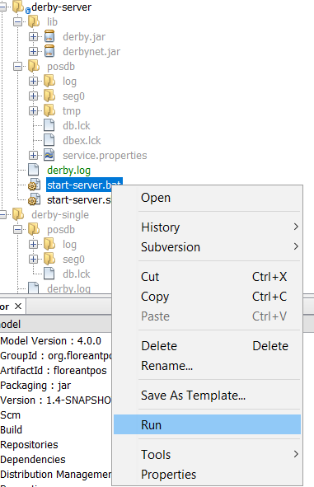

4pm-6pm: Remove Enter Pin Dialog

Found the text “Enter Pin Key” then found the Password Diaglog “

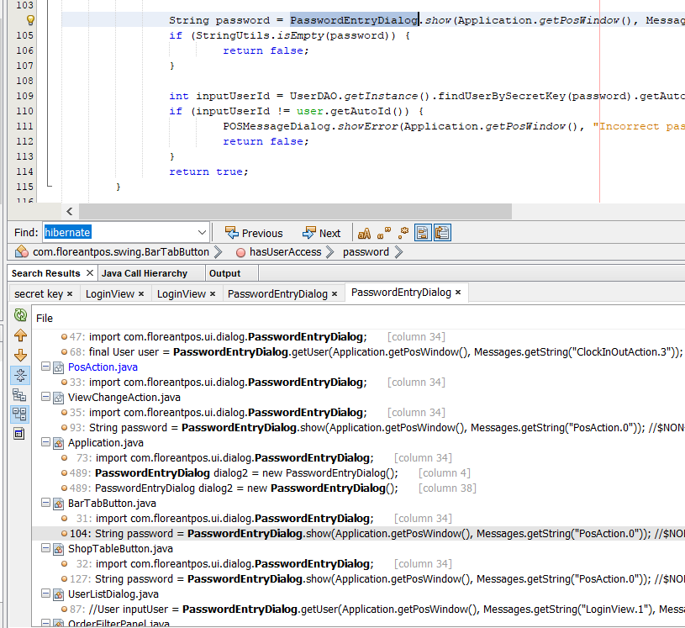

Because it seems like “Enter Pin Key” is time-consuming for staffs and the owner, so I remove this function.

I have tried to optimize the whole code but I feel it is not necessary for your task. As you said, the pin key function is not necessary and is a waste of time. The main events which lead to Login dialog happen in this below code block. I tried to use the default user which is Administrator with pass = 1111.

